**POLITICAL JUGGERNAUTS : AS QUANTITATIVE ANALYSIS OF CANDIDATES IN THE 2019 LOK SABHA ELECTION**

**INTRODUCTION**

* 1. **Overview :**

**Personality-centric politics has been a significant part of discussions on social media’s impact on electoral politics. In this study, we quantified personalization in mainstream politics by studying the extent to which parliamentary candidates referred to the key leader of their party as opposed to the party itself in their Twitter political campaigns. We found that the candidates of the incumbent right-wing Hindu nationalist party, the BJP, led by a popular and widely approved leader, Narendra Modi, were significantly more likely to run a leader-centric campaign than the candidates of the main opposition party, the INC. Smaller, state and regionalist parties showed mixed results - while candidates of some parties centralized their discourse significantly in their key leaders, in other parties’ campaigns, the party was more prominent than its leader in candidate campaigns. We also found that BJP candidates, rather than uniformly running campaigns coat tailing on their hugely popular leader, were strategic in the extent to which they ran Modi centric campaigns. For BJP candidates, their followers count, the type of constituency and Modi’s own approval rating in the region were closely associated with running Modi-centric campaigns. We found no discernible patterns in how INC candidates personalized their social media campaigns.**

**1.2 PURPOSE**

**> Accountability of government – Elections serves as the means of checking the progress of people’s representatives in the government. When the people's aspirations are not reflected in the government policies and programmes, then people can change that particular representative of government in the next elections.**

**> Legitimacy of government – Legitimacy of government means that the elected representative has the right of exercising the powers on the behalf of the citizens.**

**> Political participation – Due to the elections people can participate in elections as voters and as well as office seekers.**

**Problem Definition & Design Thinking :**

**2.1 Empathy map:**

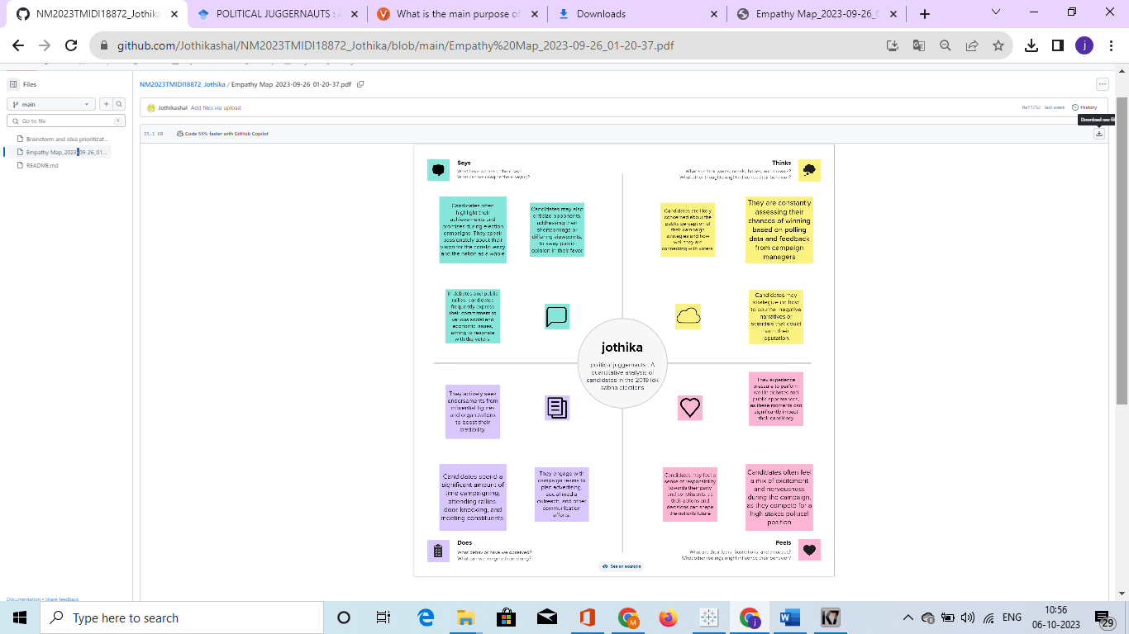

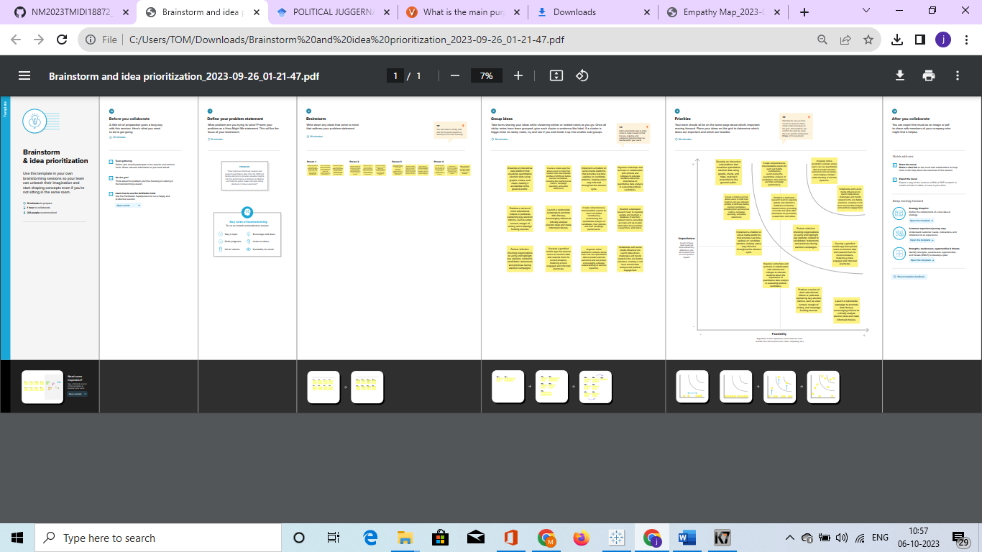**2.2 Ideation & Brainstoorming Map**

**RESULT :**



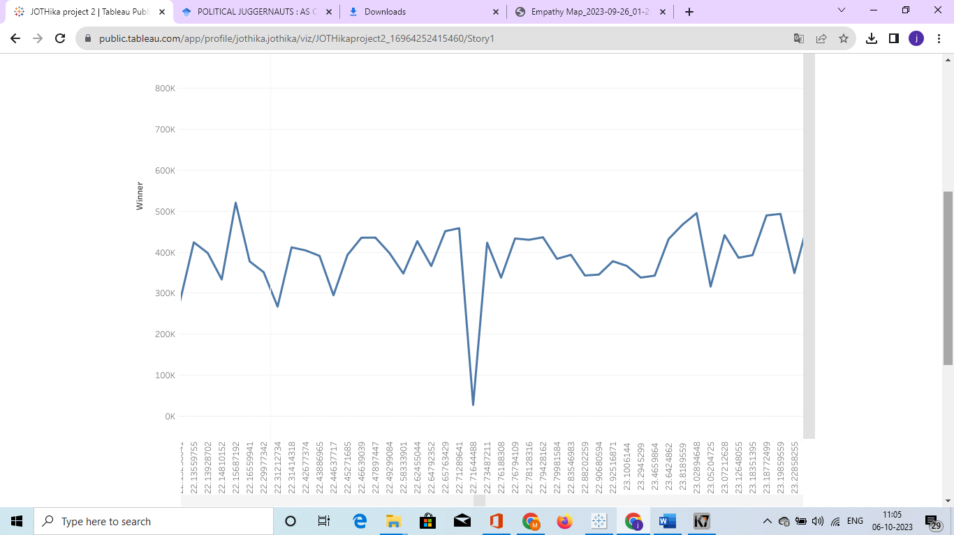

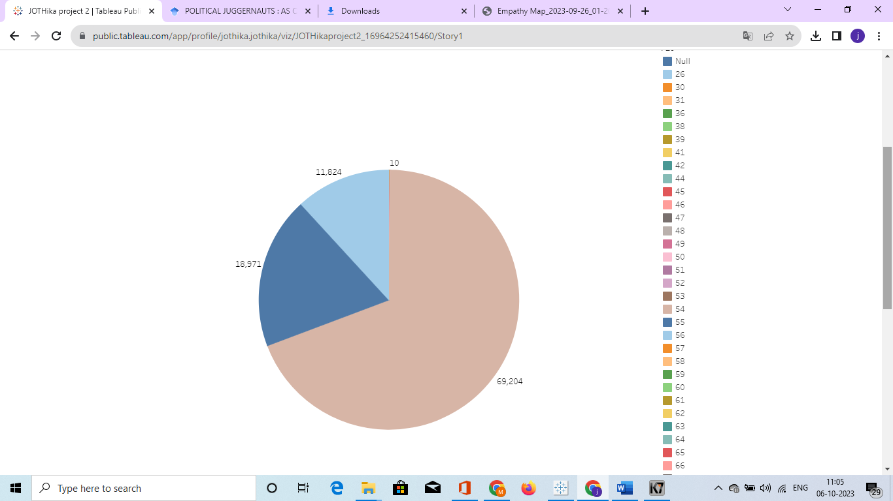

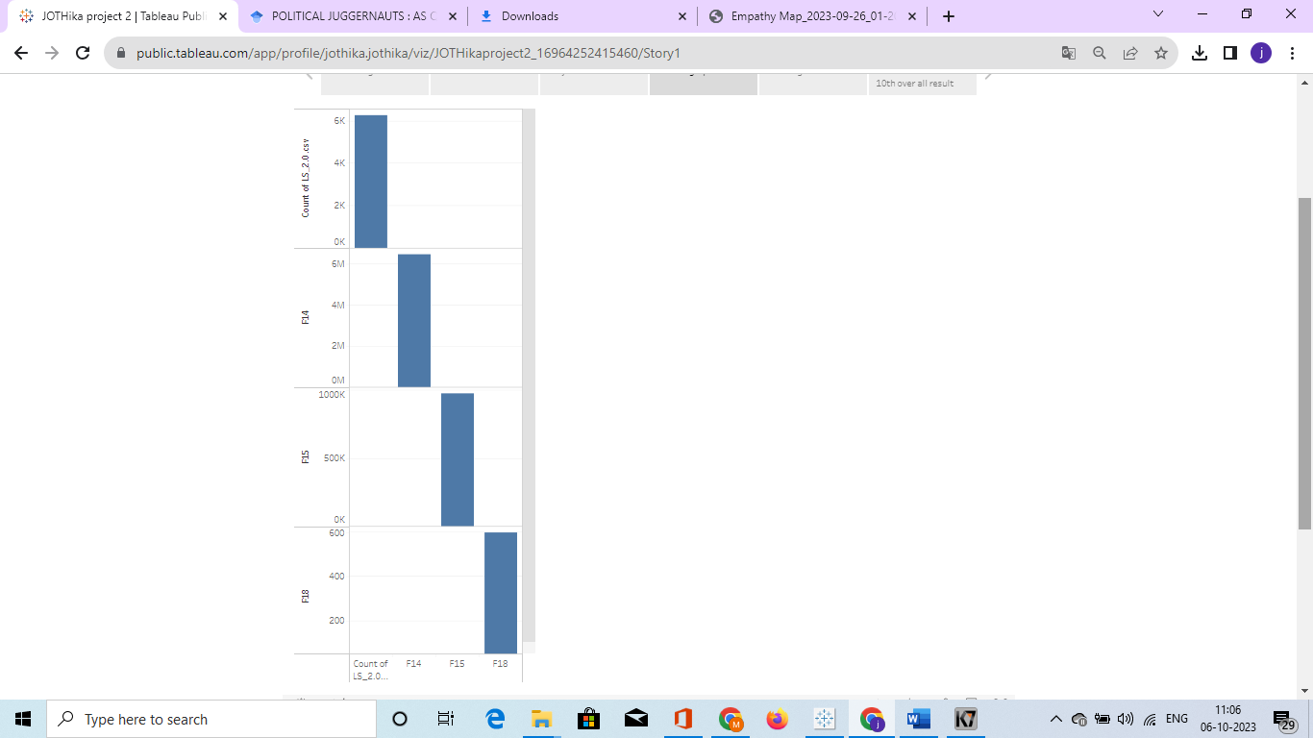

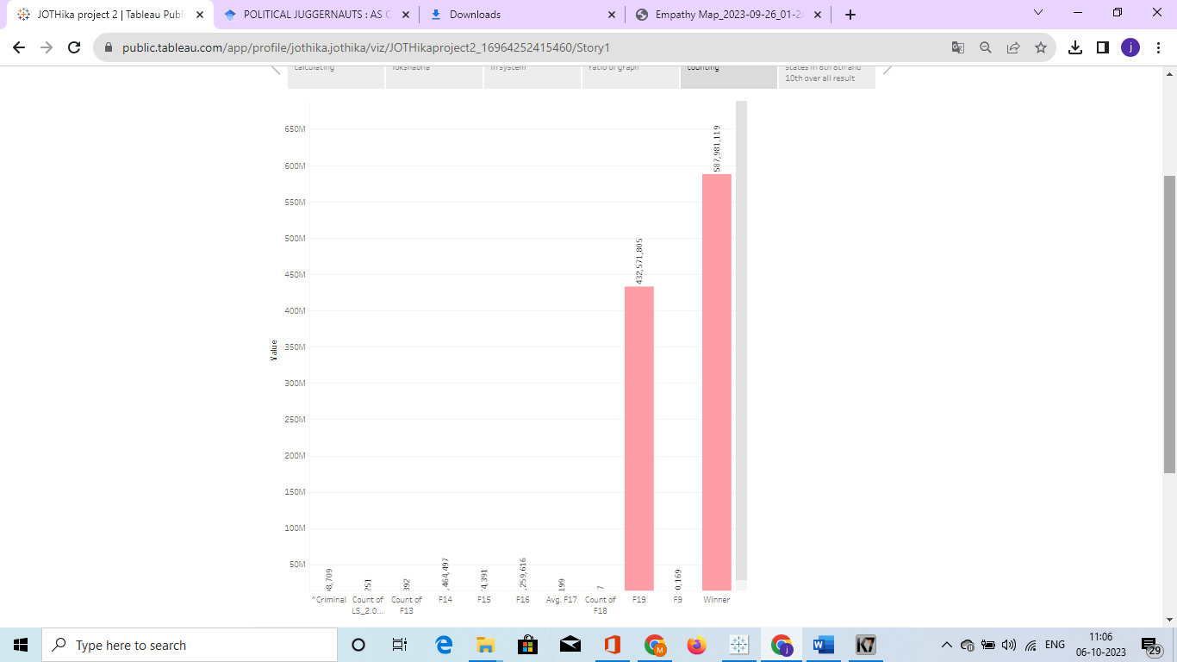

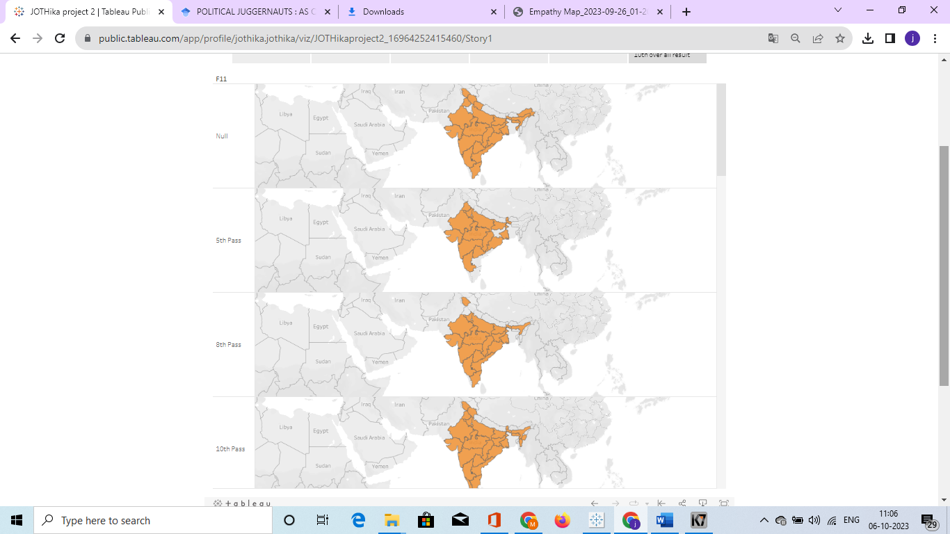

**ADVANTAGES :**

* Simultaneous elections help avoid frequent interruptions in governance due to the Model Code of Conduct, allowing governments to focus on implementing policies and reforms.
* Stable Governance It promotes stability in governance by reducing the constant cycle of elections, allowing elected representatives to concentrate on their roles without the distraction of election campaigns.
* Reduced Electoral Pressure Political parties may focus more on long-term policy implementation rather than short-term electoral gains, resulting in better decision-making.
* Streamlined Election Process Conducting elections simultaneously simplifies .

**DISADVANTAGES:**

* Coordinating elections across the entire country, India is a vast country with diverse regions, administrative complexities, and potential errors could arise due to the sheer scale of simultaneous elections.
* Potential for Dominance National political parties with larger resources and influence might have an advantage over regional or local parties in simultaneous elections.
* Longer terms in office, resulting from less frequent elections, might make political leaders less responsive to changing circumstances.
* Constitutional Changes Implementing simultaneous elections would require significant constitutional and legal changes.

**APPLICATIONS:**

* **Though the Constitution has placed both houses on the same footing in this regard, in reality, it is the Lok Sabha's opinions that mostly prevail—due to its bigger numerical strength.**
* **Equal Powers with the Rajya Sabha in initiating and passing any**[**Bill for Constitutional Amendment**](https://en.wikipedia.org/wiki/Constitution_of_India#Amendments)**(by a majority of the total membership of the House and at least two-thirds majority of the members present and voting).**
* **Equal Powers with the Rajya Sabha in initiating and passing a motion for the**[**impeachment of the President**](https://en.wikipedia.org/wiki/President_of_India#Impeachment)**(by two-thirds of the membership of the House).**
* **Equal Powers with the Rajya Sabha in initiating and passing a resolution declaring war or national emergency (by two-thirds majority) or constitutional emergency (by simple majority) in a state.**
* **If the Lok Sabha is dissolved before or after the declaration of a**[**National Emergency**](https://en.wikipedia.org/wiki/National_Emergency_in_India)**, the Rajya Sabha becomes the sole Parliament. It cannot be dissolved.**

**CONCLUSION :**

**These conclusions apply especially when the focus is on the choice between the positions and valence qualities of opposing candidates. A significant problem from the perspective of the spatial model is that incumbents are much more extreme than their district electorates, more extreme even than their partisan supporters.**

**FUTURE SCOPE :**

**Blockchain-based voting, which relies on a decentralized, distributed digital ledger is vulnerable to many of the security flaws inherent in internet voting, such as the potential for malware to alter votes on a voter’s local device before the ballot is transmitted and the lack of secret ballots. Online and blockchain-based voting would greatly increase the risk of undetectable, nation-scale election failures.**[**2**](https://www.aaas.org/epi-center/future-voting-technology#park)

**APPENDIX :**

**Intoduction :**

[**https://en.wikipedia.org/wiki/Elections_in_India**](https://en.wikipedia.org/wiki/Elections_in_India)

**ADVANTAGES :**

[**https://www.linkedin.com/pulse/advantages-disadvantages-one-nation-election-india-karthik-rajendran**](https://www.linkedin.com/pulse/advantages-disadvantages-one-nation-election-india-karthik-rajendran)

**APPLICATIONS :**

[**https://unacademy.com/content/nda/study-material/general-knowledge/understanding-lok-sabha-elections-in-detail**](https://unacademy.com/content/nda/study-material/general-knowledge/understanding-lok-sabha-elections-in-detail)

**CONCLUSION :**

[**https://www.independent.co.uk/news/world/asia/kim-jongun-wins-100-of-the-vote-in-north-korean-elections-9180814.html**](https://www.independent.co.uk/news/world/asia/kim-jongun-wins-100-of-the-vote-in-north-korean-elections-9180814.html)

**FUTURE SCOPE :**

[**https://www.aaas.org/epi-center/future-voting-technology**](https://www.aaas.org/epi-center/future-voting-technology)

THANK YOU